

RAFFLES INSTITUTION (JC)
PRELIMINARY EXAMINATION 2009

HIGHER 1

CHEMISTRY 8872/01
Paper 1 Multiple Choice 24 September 2009
50 minutes

Additional Materials: Multiple Choice Answer Sheet
Data Booklet

READ THESE INSTRUCTIONS FIRST

Do not open this question booklet until you are told to do so.

Write in soft pencil.
Do not use staples, paper clips, highlighters, glue or correction fluid.
Write your name, class and index number in the spaces provided on the Answer Sheet.

There are thirty questions on this paper. Answer all questions.

For each question there are four possible answers A, B, C and D.
Choose the one you consider to be correct and record your choice with a soft pencil on the separate Answer Sheet.

Read the instructions on the Answer Sheet very carefully.

Each correct answer will score one mark. A mark will not be deducted for a wrong answer. Any rough working should be done in this booklet.

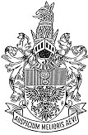
This document consists of 14 printed pages.

Raffles Institution

Junior College

Section A

For each question, there are four possible answers, A, B, C, and D. Choose the one you consider to be correct and record your choice on the Multiple Choice Answer Sheet provided.

1. | Naturally occurring silicon is a mixture of three isotopes, ²⁸Si, ²⁹Si and ³⁰Si. The relative atomic mass of silicon is 28.109.  What could be the relative abundance of each of the three isotopes?
 | A | 91.1 % ²⁸Si, 7.9 % ²⁹Si and 1.0 % ³⁰Si
 | B | 92.2 % ²⁸Si, 4.7 % ²⁹Si and 3.1 % ³⁰Si
 | C | 95.0 % ²⁸Si, 3.2 % ²⁹Si and 1.8 % ³⁰Si
 | D | 96.3 % ²⁸Si, 0.3 % ²⁹Si and 3.4 % ³⁰Si
2. | 10 cm³ of a hydrocarbon was completely burnt in 100 cm³ of oxygen. The volume of the residual gas obtained was 80 cm³. When the residual gas was shaken with aqueous sodium hydroxide, the volume decreased to 20 cm³. Which one of the following represents the structure of the hydrocarbon? (All volumes are measured at room temperature and pressure).
 | A | 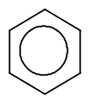 | C | 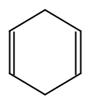
 | B | 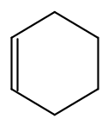 | D | 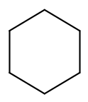
3. | 20.0 cm³ of 0.0200 mol dm⁻³ bromate(V), BrO₃⁻, was found to react completely with 80.0 cm³ of 0.0100 mol dm⁻³ hydroxylamine, NH₂OH. BrO₃⁻ ions are reduced as follows:  BrO₃– + 6e– + 6H⁺ → Br⁻ + 3H₂O  Which of the following could be the half-equation for the oxidation of hydroxylamine?
 | A | NH₂OH → ½N₂O + 2H⁺ + ½H₂O + 2e⁻
 | B | NH₂OH → NO + 3H⁺ + 3e⁻
 | C | NH₂OH + H₂O → NO₂⁻ + 5H⁺ + 4e⁻
 | D | NH₂OH + 2H₂O → NO₃⁻ + 7H⁺ + 6e⁻

4. | The following reaction is used in the titration of iron(II) solution with acidified potassium dichromate(VI).  6Fe²⁺ + Cr₂O₇^{2–} + 14H⁺ ⎯→ 6Fe³⁺ + 2Cr³⁺ + 7H₂O  If 50.0 cm³ of an iron(II) solution require 45.20 cm³ of 0.100 mol dm^{–3} potassium dichromate(VI) for reaction, what is the mass of Fe²⁺ ions in 1 dm³ of the iron(II) solution?
 | A | 12.6 g
 | B | 25.2 g
 | C | 30.3 g
 | D | 60.5 g
5. | The successive ionisation energies, in kJ mol⁻¹, of an unknown element E are given below:  Which of the following statements about E is correct?
  703 | 1610 | 2460 | 4350 | 5400 | 8500 | 10300 | 12300
 | A | E is in Group II of the Periodic Table.
 | B | The oxide of E is an amphoteric oxide.
 | C | The chloride of E hydrolyses in water to give an acidic pH.
 | D | E can conduct electricity in the solid and molten state.
6. | Of the following, which is the strongest oxidising agent?
 | A | O₂⁺
 | B | O₂
 | C | O₂–
 | D | O₂^{2–}
7. | Which one of the following sets of compounds consists of a giant ionic structure, a giant covalent structure and a simple covalent structure?
 | A | C₆H₅CO₂H, P₄O₁₀ and SiC
 | B | BaO₂, ICl₃ and H₃PO₄
 | C | C(diamond), AlCl₃ and BCl₃
 | D | BCl₃ , BaCl₂ and SiO₂
8. | Which of the following best describes the change in bond angle in water when the ion H₃O⁺ is formed?
 | A | increases to approximately 107º
 | B | increases to approximately 109º
 | C | decreases to approximately 107º
 | D | decreases to approximately 109º
9. | Which of the equations correctly defines the standard enthalpy change of formation of a compound?
 | A | Na(s) + Cl(g) ⎯→ NaCl(s)
 | B | 2H₂(g) + O₂(g) ⎯→ 2H₂O(l)
 | C | C(s) + O₂(g) ⎯→ CO₂(g)
 | D | K(s) + Mn(s) + 2O₂(g) ⎯→ KMnO₄(l)
10. | The enthalpy change of reaction, ΔH_{r}, between calcium and water to produce calcium hydroxide and hydrogen gas can be measured in the laboratory.  ΔH_{r}  Ca(s) + O₂(g) + 2H₂(g)  Ca(s) + 2H₂O(l) Ca(OH)₂(s) + H₂(g)  What information, other than that obtained in the experiment above, is needed to calculate a value for the enthalpy change of formation of Ca(OH)₂(s)?
 | A | enthalpy change of vapourisation of calcium
 | B | enthalpy change of combustion of hydrogen
 | C | first and second ionisation energies of calcium
 | D | lattice energy of calcium hydroxide
11. | Methanol is manufactured industrially by the catalytic reaction shown:  CO(g) + 2H₂(g) 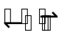CH₃OH(g) ΔH = −92 kJ mol⁻¹  The operating conditions are 250 °C, a pressure of 75 atm and a copper-based catalyst.  Which factor influences the choice of these conditions?
 | A | The catalyst increases the equilibrium yield of methanol.
 | B | At lower pressures, the rate of formation of methanol increases.
 | C | At lower temperatures, the rate of formation of methanol increases.
 | D | At lower temperatures, the equilibrium yield of methanol increases.
12. | V and W can react together to reach equilibrium in the reaction below.  V(g) + W(g) X(g) + Y(g)  In an experiment, 1.0 mole each of V and W were reacted at constant pressure P and temperature 350 ºC. The amount of Y present in the mixture at intervals of time was recorded. The experiment was repeated at the same pressure P, but at a temperature of 700 ºC. The results for both experiments are shown below.  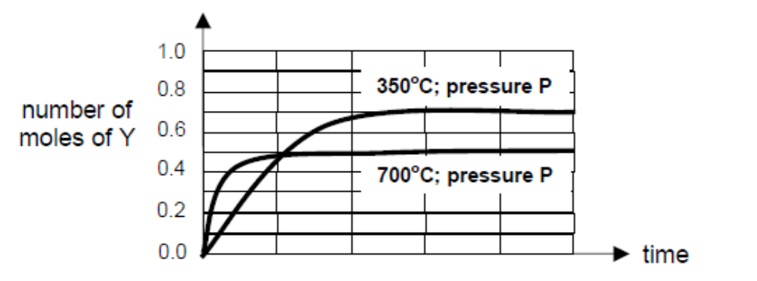  Which one of the following information cannot be deduced from the graph?
 | A | The activation energy of the forward reaction is high.
 | B | The enthalpy change for the forward reaction is negative.
 | C | The value of K_{c} decreases with an increase in temperature.
 | D | The rate at which equilibrium is achieved is faster at higher temperatures.
13. | Which substance, in 1 mol dm⁻³ aqueous solution, would have the same hydrogen ion concentration as 1 mol dm⁻³ of hydrochloric acid?
 | A | sodium hydroxide
 | B | ethanoic acid
 | C | sulfuric acid
 | D | nitric acid
14. | For the reaction L(aq) + 2M(aq) ⎯→ N(aq), the rate equation is  Rate = k [H⁺][M]²  Which of the following statements is incorrect?
 | A | H⁺ is a catalyst in the reaction.
 | B | When the concentration of L is halved, the rate remains unchanged.
 | C | The unit for the rate constant is mol⁻² dm⁶ s⁻¹.
 | D | If the concentration of M is doubled, the rate of the experiment increases by two times.
15. | Iodine reacts with propanone according to the equation:  I₂ + CH₃COCH₃ → CH₃COCH₂I + HI  The reaction of iodine with propanone is found to be zero order with respect to iodine.  Which graph correctly show how the [I₂] changes with time?
 | A | [I₂]  Time  0 |  |  |  | C | [I₂]  Time  0
 | B | [I₂]  Time  0 |  |  |  | D | [I₂]  Time  0
16. | The highest oxides of the elements sodium to chlorine are separately added to water.  Which diagram best represents the pH of the solutions produced?
 | A | 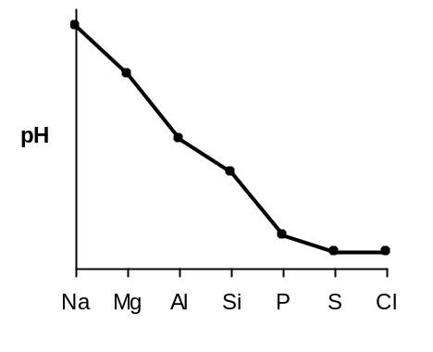 |  |  |  | C | 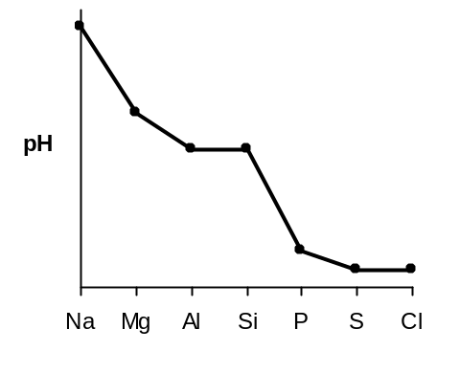
 | B | 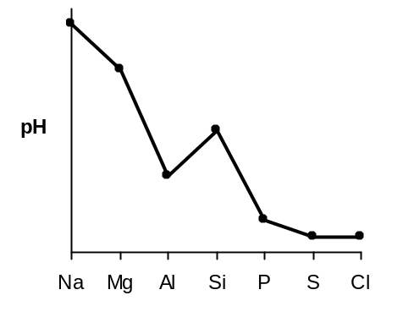 |  |  |  | D | 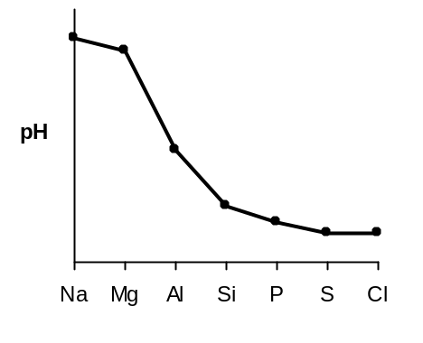
17. | Two solutions were prepared by dissolving a chloride and an oxide of the elements in the third period of the Periodic Table in separate portions of water.  Both solutions prepared can be used to dissolve Al₂O₃ but only one can be used to dissolve SiO₂.  Which of the following could be the chloride and the oxide used?
 | A | NaCl and SO₃
 | B | PCl₅ and Na₂O
 | C | MgCl₂ and MgO
 | D | SiCl₄ and P₄O₁₀
18. | Vitamin A plays a role in many functions throughout the human body such as vision, gene transcription, bone metabolism and skin health. The diagram below shows the structure of vitamin A.  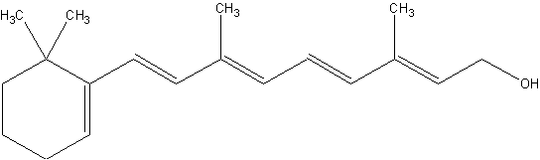  What is the total number of cis-trans isomers of this molecule?
 | A | 8
 | B | 10
 | C | 16
 | D | 32
19. | How many isomers are possible for the aromatic compound, containing a C=C double bond, of molecular formula C₈H₇Cl (including both structural and stereo-isomers)?
 | A | 5
 | B | 6
 | C | 7
 | D | 8
20. | Which one of the following alcohols will give the largest number of alkenes when treated with concentrated sulfuric acid?
 | A | CH₃CH(OH)CH₂CH₃
 | B | (CH₃)₃COH
 | C | CH₃(CH₂)₃OH
 | D | CH₃CH₂CH(OH)CH₂CH₃
21. | Which one of the following represents the final product obtained when the alkene below is reacted with cold, alkaline manganate(VII) ions followed by refluxing with hot acidified dichromate(VI) solution?  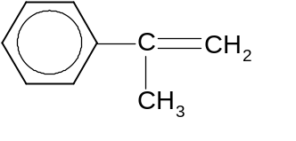
 | A | 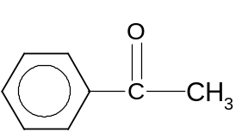 |  |  |  | C | 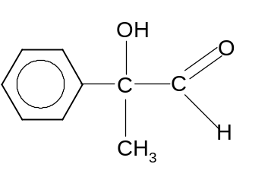
 | B | 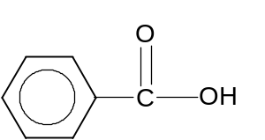 |  |  |  | D | 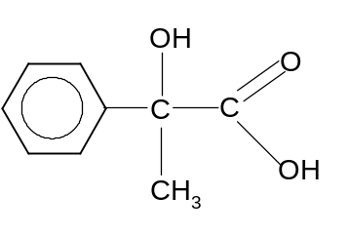
22. | A reaction sequence is given below.  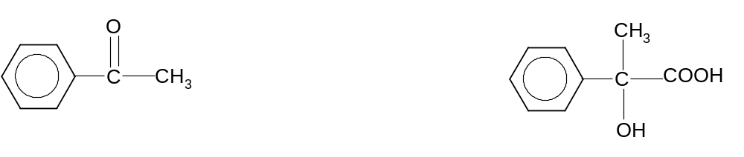  P  Which one of the following pairs corresponds to the correct reagents and conditions for stages I and II?
 |  | Stage I |  | Stage II
 | A | LiAlH₄ in dry ether |  | KMnO₄, dilute H₂SO₄, reflux
 | B | HCN, trace NaOH |  | dilute H₂SO₄, reflux
 | C | ethanolic KCN |  | LiAlH₄ in dry ether
 | D | ethanolic KCN |  | dilute H₂SO₄, reflux
23. | What are the products formed when compound G is treated with an excess of hot acidified KMnO₄?  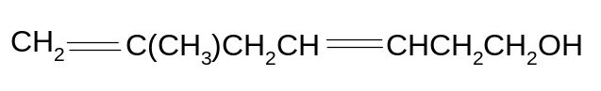  Compound G
 | A | CO₂ | 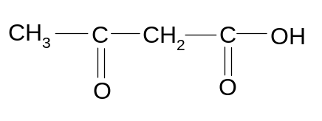 |  | 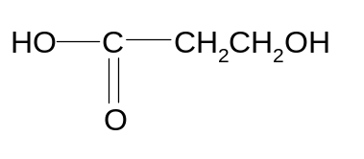
 | B | CO₂ | 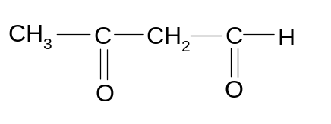 |  | 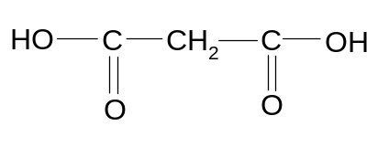
 | C | CO₂
 | D | CO₂
24. | Which reagent gives the same visible result with propanal and with propan-2-ol?
 | A | Fehling’s reagent
 | B | Concentrated sulfuric acid
 | C | Hot acidified potassium manganate(VII)
 | D | 2,4-dinitrophenylhydrazine

25. | The structure of an organic compound V is shown below:  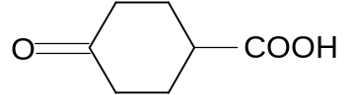  Compound V  Which one of the following statements is true?
 | A | The six-membered carbon ring in V is planar.
 | B | V reacts readily with cold HCN under acidic conditions.
 | C | V changes warm acidified aqueous potassium dichromate(VI) from orange to green.
 | D | Reaction of sodium carbonate with V produces a gas which forms a white precipitate with aqueous calcium hydroxide.

Section B

For each of the following questions, one or more of the three numbered statements 1 to 3 may be correct. Decide whether each of the statements is or is not correct (you may find it helpful to put a tick against the statements that you consider to be correct).

The responses A to D should be selected on the basis of

A | B | C | D
1, 2 and 3  are  correct | 1 and 2  only are  correct | 2 and 3  only are  correct | 1 only  is  correct

No other combination of statements is used as a correct response.

26. | Which of the following statements are correct for the sequence of compounds below considered from left to right?  NaF MgO AlN SiC
 | 1 | The electronegativity difference between the elements in each compound increases.
 | 2 | The formula-units of these compounds are isoelectronic.
 | 3 | The bonding becomes increasingly covalent.
27. | The graph below shows the Boltzmann distribution of molecular energies at a given temperature.  energy  0  proportion of molecules  As temperature increases, which statements are correct?
 | 1 | The maximum of the curve is displaced to the right.
 | 2 | The proportion of molecules with energies above any given value increases.
 | 3 | The proportion of molecules with any given energy increases.

The responses A to D should be selected on the basis of

A | B | C | D
1, 2 and 3  are  correct | 1 and 2  only are  correct | 2 and 3  only are  correct | 1 only  is  correct

No other combination of statements is used as a correct response.

28. | Carbon nanotube is an allotrope of carbon with a cylindrical nanostructure. The cylindrical carbon molecules have novel properties that make them potentially useful in many applications in nanotechnology and electronics. A single wall carbon nanotube is given in the diagram below:  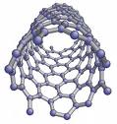  Which of the following properties is expected of the nanotube?
 | 1 | The carbon atoms are sp² hybridised.
 | 2 | It contains delocalised electrons.
 | 3 | It can conduct electricity.
29. | In which of the folllowing pairs of compounds does the first one have a higher boiling point than the second?
 | 1 | 2,2-dimethylpropane | 2-methylbutane
 | 2 | cis-2,3-dichlorobut-2-ene | trans-2,3-dichlorobut-2-ene
 | 3 | 4-nitrophenol | 2-nitrophenol

The responses A to D should be selected on the basis of

A | B | C | D
1, 2 and 3  are  correct | 1 and 2  only are  correct | 2 and 3  only are  correct | 1 only  is  correct

No other combination of statements is used as a correct response.

30. | Bacteria have been suggested as a possible means of cleaning up oil spillages. Some bacteria contain certain enzymes that can insert one or more oxygen atoms into any carbon-hydrogen bond in an alkane. This converts a water-insoluble alkane into a water-soluble alcohol, e.g.  CH₃CH₃ 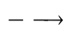 CH₃CH₂OH  Which of the following alcohols could be obtained by this process from (CH₃)₂CHCH₂CH₃?
 | 1 | (CH₃)₂C(OH)CH(OH)CH₃
 | 2 | CH₃CH(OH)CH(CH₃)₂
 | 3 | CH₃CH₂CH(CH₂OH)₂

